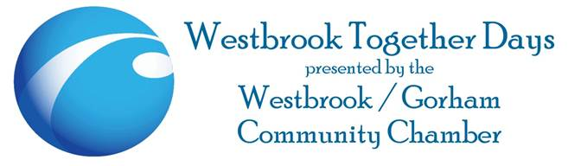

**The Leona Glidden Westbrook Together Days Auction!**

Dear Business Owner:

**This year’s** **Westbrook Together Days ( WTD’s) will be our 38th year of celebration**.

We will be celebrating WTD’s on June 2nd and June 3rd, 2017.  This celebration, hosted by the Westbrook/Gorham Chamber of Commerce, is held at Riverbank Park on Main Street.  This is the largest community event in Westbrook, attracting +20,000 people over two days!

**With the help of local business owners, the auction raised over $10,000 last year!  The proceeds help fund scholarships for our local high school students and fund WTD 2018.**

**We would love to have you involved in the 2017 auction, which will be held on Saturday, June 3rd!  It is a great opportunity to gain recognition for your business as well as show support for the community.**

Please consider donating this year. We will accept new items, gift certificates, or services.  We promise to highlight your business before and during the auction.  We will list your company’s name, link and donation on our website [(www.WestbrookTogetherDays.com](http://(www.westbrooktogetherdays.com/)) and Facebook page.

A member of our auction committee would be happy to pick up your donation, at your convenience.  We can also create gift certificates for you if one is needed for a particular item or service.  Donations can also be dropped off at Avita of Stroudwater, 113 Landing Road Westbrook, or mailed to Westbrook Together Days, P.O. Box 1223, Westbrook, ME 04098.

Please contact Lea Rust at 207-844-0899 or [lea@avitaofstroudwater.com](mailto:lea@avitaofstroudwater.com) , if you have any questions or would like to schedule a pick-up of your donation.

Thank you in advance for your consideration!

Sincerely,

Lea Rust

Auction Committee Co-Chair